Deploying EasyTravel on AWS EC2 with Docker & Dynatrace Monitoring
Objective
This lab guides you through:
- Creating an EC2 instance with Amazon Linux AMI
- Installing Docker and Docker Compose
- Deploying the Dynatrace EasyTravel demo app
- Integrating with Dynatrace OneAgent
- Troubleshooting missing logs

Prerequisites
- AWS account with access to launch EC2 instances
- Dynatrace SaaS account with API token for OneAgent installation
- SSH key pair (.pem) for EC2 login

Step 1: Launch EC2 Instance
- Go to AWS Console → EC2 → Launch Instance
- Choose Amazon Linux 2 AMI (HVM), SSD Volume Type
- Select t2.medium or higher (for Docker container support)
- Configure:
  - Security Group with inbound rules for:
    - SSH (port 22)
    - HTTP (port 80)
    - Custom TCP: 8079, 8080, 8081 (used by EasyTravel)
- Add key pair (.pem) and launch the instance
Screenshot Placeholder:
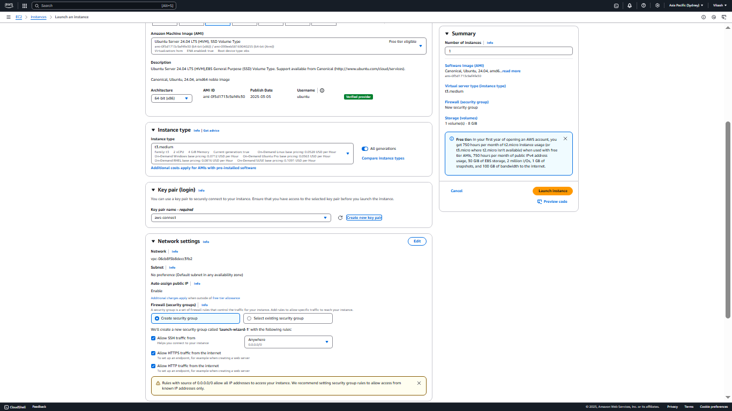

Step 2: Connect to EC2 Instance
Use the downloaded key pair to connect via SSH:
bash
ssh -i your-key.pem ec2-user@<EC2_PUBLIC_IP>

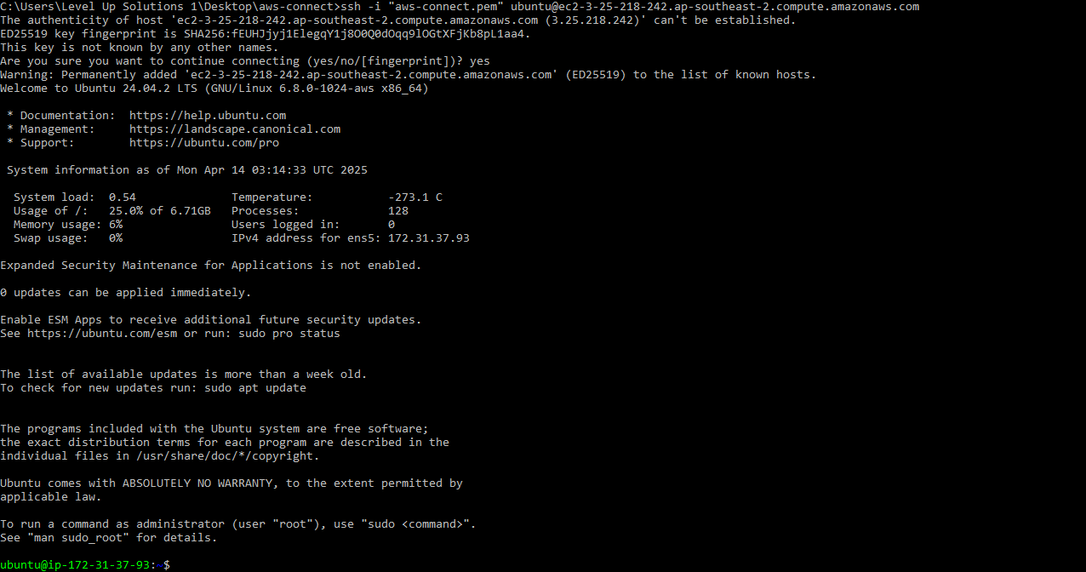

Step 3: Install Docker and Dependencies
Run the following commands on the EC2 instance:
bash
sudo yum update -y
sudo yum install -y docker git libxcrypt-compat
Start Docker and allow EC2 user to run Docker:
bash
sudo service docker start
sudo usermod -a -G docker ec2-user
newgrp docker
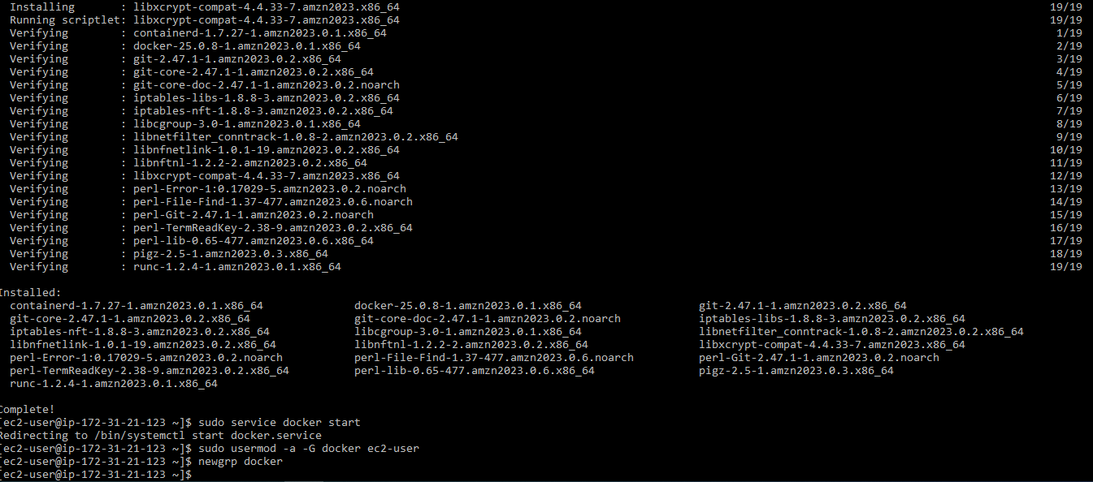

Step 4: Install Docker Compose
Install Docker Compose (v1.29.2):
bash
sudo curl -L "https://github.com/docker/compose/releases/download/1.29.2/docker-compose-$(uname -s)-$(uname -m)" -o /usr/local/bin/docker-compose
sudo chmod +x /usr/local/bin/docker-compose
Verify installation:
bash
docker-compose –version
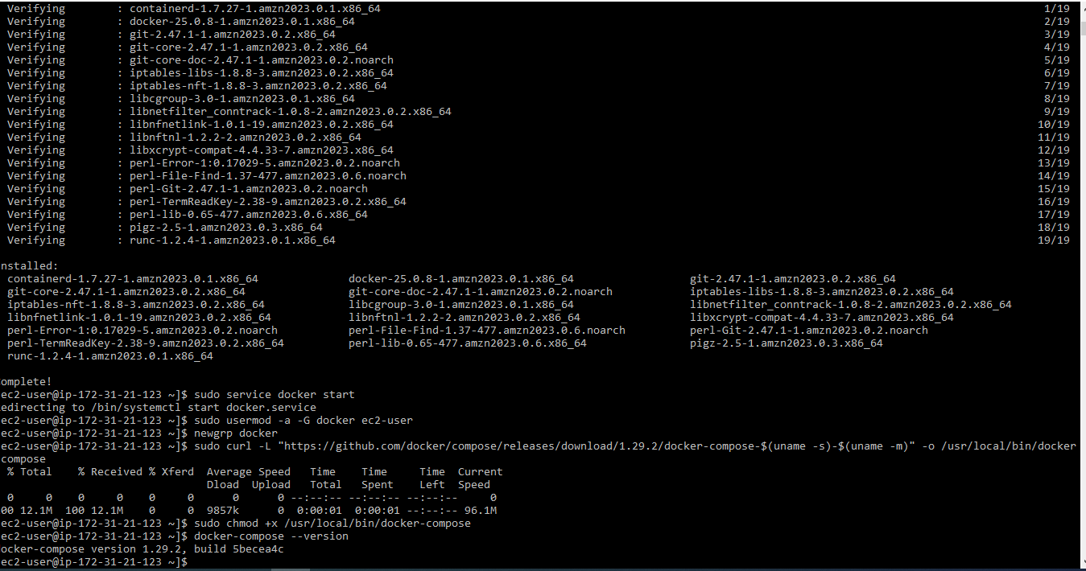

Step 5: Clone and Run EasyTravel Application
Clone the Dynatrace EasyTravel Docker project:
bash
git clone https://github.com/Dynatrace/easyTravel-Docker.git
cd easyTravel-Docker
Start EasyTravel containers:
bash
docker-compose up -d
This will launch multiple services (frontend, backend, database) used to simulate a full-stack application.
Screenshot Placeholder:
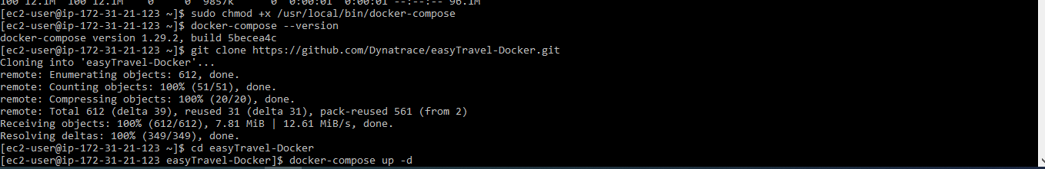docker ps
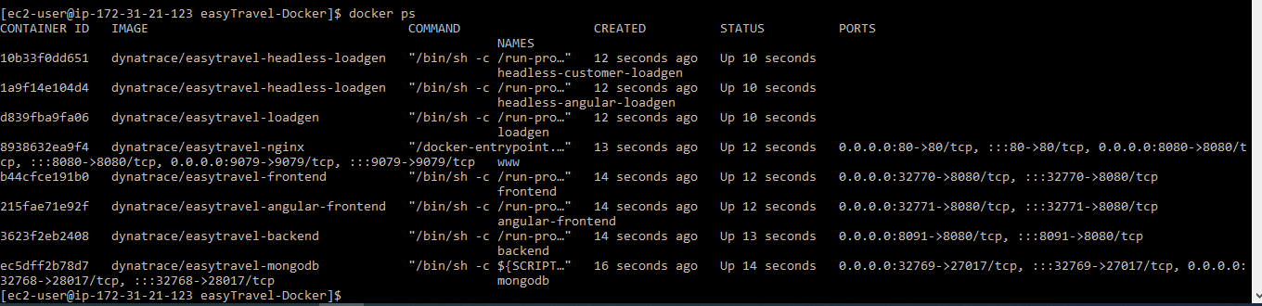

Step 6: Access EasyTravel Application
Open your browser and navigate to:
http://<EC2_PUBLIC_IP>
Screenshot Placeholder:
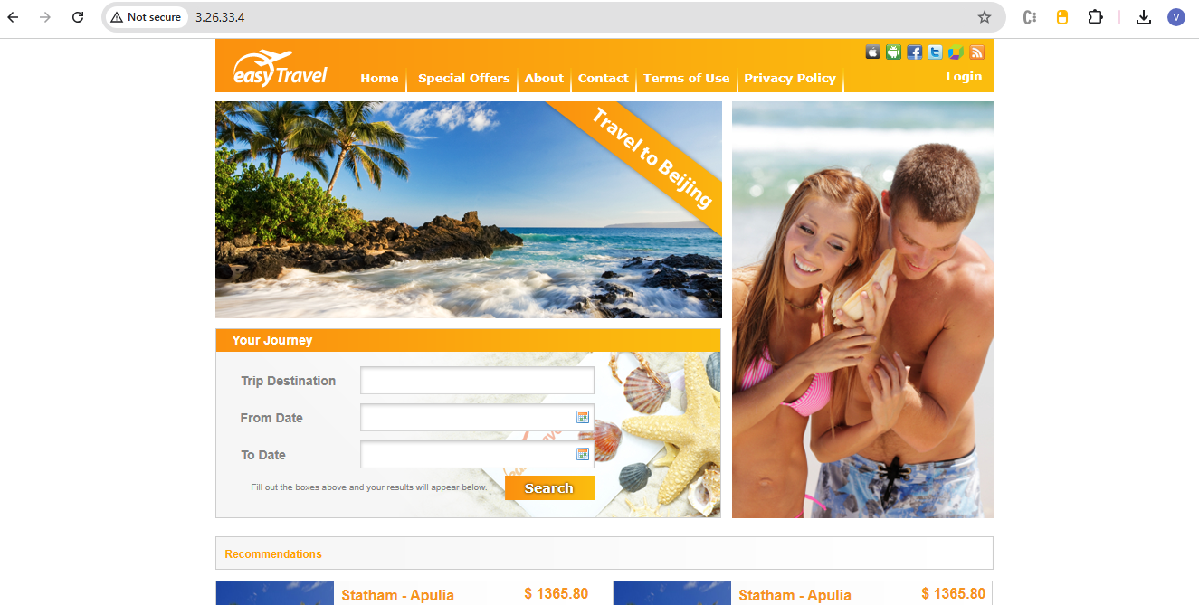
Step 7: Install Dynatrace OneAgent
- Log into your Dynatrace SaaS dashboard
- Navigate to Deploy Dynatrace → Start Installation → Linux
- Copy the OneAgent installation script
- On the EC2 instance, run the copied script, e.g.:
bash
wget -O Dynatrace-OneAgent.sh "https://<TENANT_ID>.live.dynatrace.com/api/v1/deployment/installer/agent/unix/default/latest?Api-Token=<TOKEN>&arch=x86&flavor=default"
sudo /bin/sh Dynatrace-OneAgent.sh
This installs the OneAgent which automatically detects containers and services.
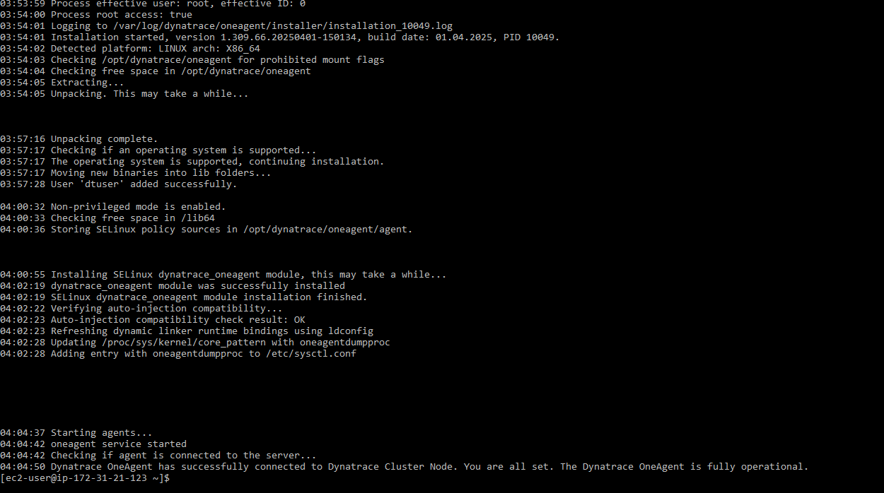

Step 8: Verify Monitoring in Dynatrace
- Go to Dynatrace UI → Hosts
- You should see your EC2 instance with Docker processes
- Navigate to Processes or Docker containers
- Check if EasyTravel services (frontend, backend, DB) are being monitored
Screenshot Placeholder: Dynatrace UI showing EC2 and containers

Step 9: Troubleshooting – Logs Not Appearing?
Sometimes OneAgent might not capture container logs immediately. To fix:
Restart containers:
bash
docker-compose down
docker-compose up -d
Confirm containers are running:
bash
docker ps
After restarting, check Dynatrace again for:
- Container metrics
- Log ingestion
- Service response time and throughput

Lab Outcome
You have successfully:
- Launched a Linux EC2 instance
- Installed Docker & Docker Compose
- Deployed the EasyTravel demo app
- Integrated Dynatrace OneAgent
- Viewed app metrics and logs in Dynatrace

